Name:
Date:
08.07 Picture Lab Worksheet
Directions: Make note of your responses to the following questions as you work through the activities and exercise in the lesson.
Activity 5 Questions
Question | Yes | No
- Is the method getPixels2D in the Picture.java class? | Yes
- Is the method getPixels2D in the SimplePicture.java class? |  | No
- Will the following code compile?  DigitalPicture p = new DigitalPicture(); |  | No
- Assuming a no-argument constructor exists for SimplePicture, will the following code compile?  DigitalPicture p = new SimplePicture(); | Yes
- Assuming a no-argument constructor exists for Picture, will the following code compile?  DigitalPicture p = new Picture(); | Yes
- Assuming a no-argument constructor exists for Picture, will the following code compile?  SimplePicture p = new Picture(); | Yes
- Assuming a no-argument constructor exists for SimplePicture, will the following code compile?  Picture p = new SimplePicture(); |  | No

Activity 5 Exercise Results

- Describe your method for keepOnly red, blue, or green.
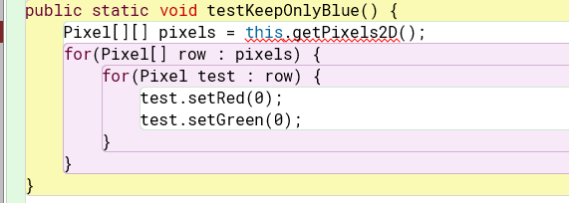
Set Red and Green to be gone so that only Blue is left
- For the negate method, paste your code related to calculating and setting the values for red, blue, and green.
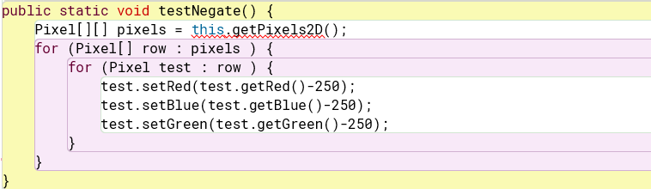

- Paste a copy of the image that is the result of calling the grayscale.
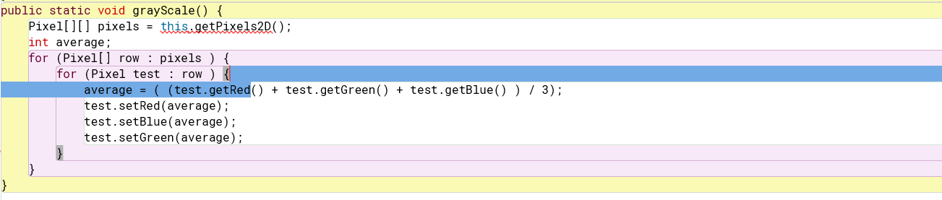
- For the method fixUnderwater, describe the algorithm you'd propose to accomplish the task.
To make the fish easier to be seen, I would set the colors blue and green to be at the highest point rather than in the middle. That ways it will be easier to distinguish which is which when glancing at the photo.

Activity 6 Exercise Results
- Paste the image that is the result of calling the method mirrorVerticalRightToLeft.
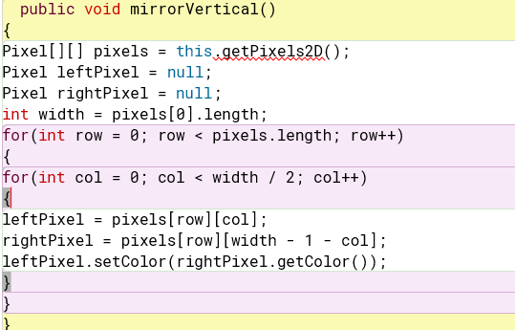
- Describe the algorithm for the method mirrorHorizontal works.
Rather than using right to left you would use top to bottom.

- Paste the image that is the result of calling the method mirrorHorizontalBotToTop.

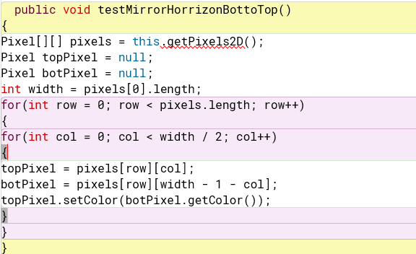

Activity 7 Questions
  - How many times would the body of this nested for loop execute? 9 * 10 =90
for(int row = 7; row < 17; row++)
for(int col = 6; col < 15; col++)
  - How many times would the body of this nested for loop execute? 7 * 16 = 112
for(int row = 5; row <= 11; row++)
for(int col = 3; col <= 18; col++)

Activity 7 Exercise Results

- What value is displayed for count after the nested loop ends in the mirrorTemple method? ????
- Paste the image that is the result of calling the method mirrorArms.
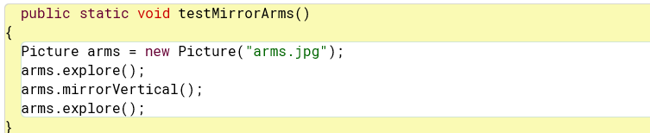
- Paste the image that is the result of calling the method mirrorGull.
